MM5425 HomeworkPlus: Linear Regression
Objectives:
- Gently get started with how to use Pandas in python
- Check the attributes' relevance using the correlation
- Predict accurately the insurance cost with multivariate linear regression
- Check the performance metrics of the linear regression model
Part I: Python Basics ~ function
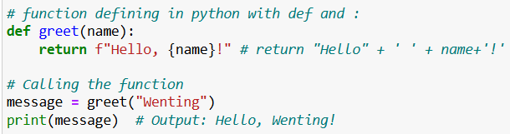
Exercise 1.1: Sales Tax Calculator
Write a function called calculate_sales_tax that takes two arguments: the price of an item and the sales tax rate (as a percentage). The function should return the total price including sales tax. Call the function and display the total for $170 with 12.5% tax rate.
Exercise 1.2: Employee Bonus Calculator
Task: Write a function called calculate_bonus that takes two arguments: the employee's salary and the performance rating (an integer from 1 to 5). The function should return the bonus amount based on the following criteria:
Rating 5: 20% of salary
Rating 4: 15% of salary
Rating 3: 10% of salary
Rating 2: 5% of salary
Rating 1: 0% of salary
Try the function to calculate the bonus for an employee with salary 28000 and performance rating is 3.
Part II: Linear Regression with Excel
Download the dataset insurance.csv from Blackboard in WK4. Open the file and check the contents.
This dataset has 1 target variable and 6 independent variables:
Age: age of primary beneficiary.
Gender: insurance contractor gender, female, male.
BMI: Body mass index, providing an understanding of body, weights that are relatively high or low relative to height, objective index of body weight (kg/m^2) using the ratio of height to weight, ideally 18.5 to 24.9.
Children: Number of children covered by health insurance/Number of dependents.
Smoker: Is the person a smoker or not.
Region: the beneficiary’s residential area in the US, northeast, southeast, southwest, northwest.
Charges: Individual medical costs billed by health insurance.
- Open file insurance.csv
- Select "Data" from the toolbar. The "Data" menu displays.
- Select "Data Analysis". The Data Analysis - Analysis Tools dialog box displays.
  - If you don’t see ‘Data Analysis’,
for Windows system, you need:
      - In your Excel, click File > Options.
      - In the Excel Options dialog box, select Add-ins on the left sidebar, make sure Excel Add-ins is selected in the Manage box, and click Go.
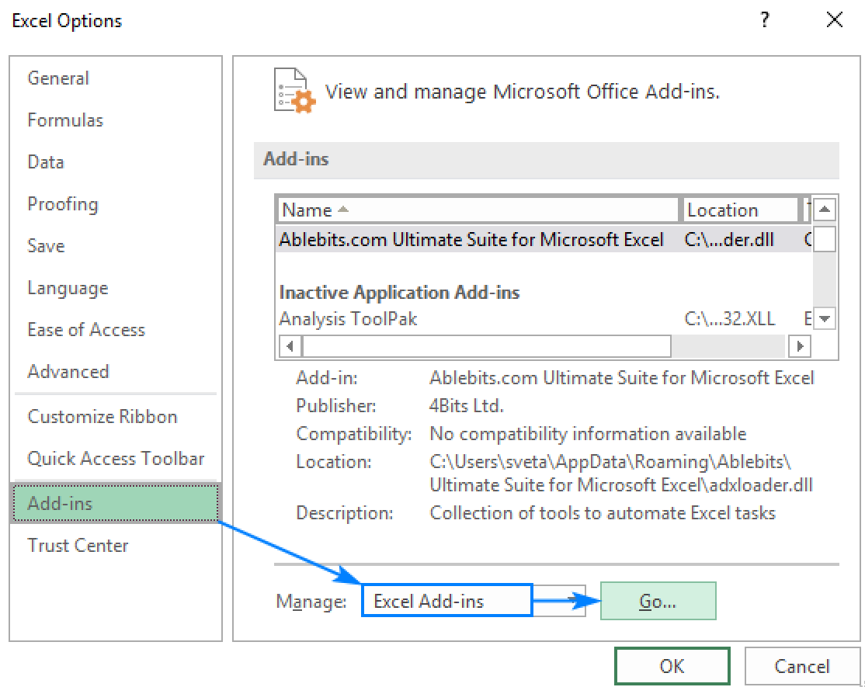
      - In the Add-ins dialog box, tick Analysis Toolpak, and click OK. That will add Data Analysis tools to the Data tab to your excel
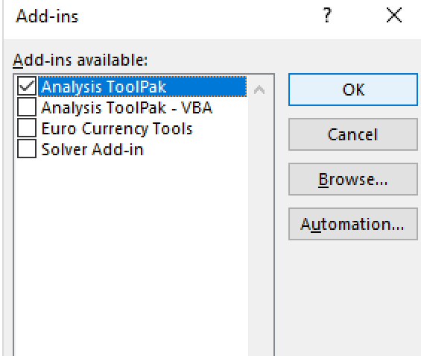

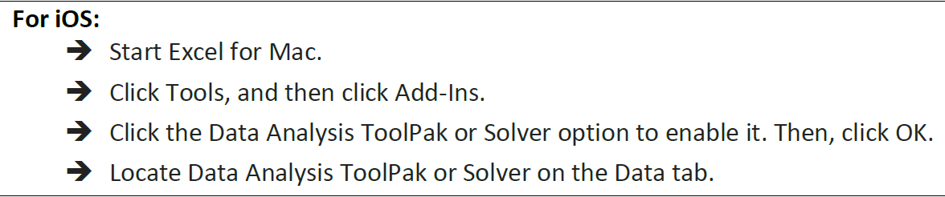
- From the menu, select "Regression" and click "OK".
- In the Regression dialog box, click the "Input Y Range" box and select the dependent variable data. Try the following options:
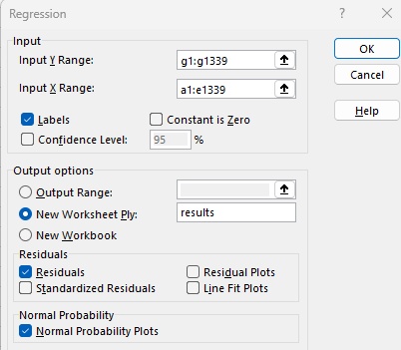
- There’s an error message showing that only numerical data can be used in the linear regression. Therefore, pressing ctrl+f keys, we replace ‘yes’ with 1, ‘no’ with 0, ‘female’ with 0, ‘male’ with 1
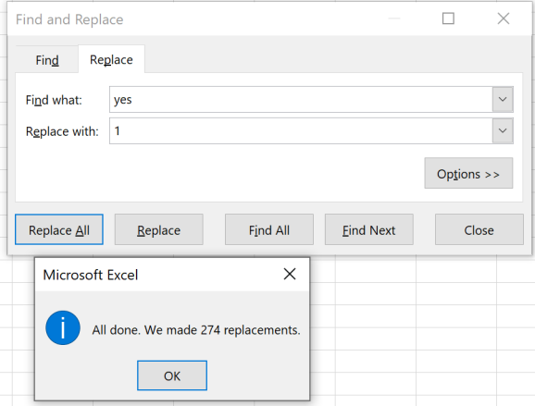
(Question: what do we do with column region?)

- Try the regression dialog box again.

- Check the results in excel. Look for the following statistics:
Adjusted R square: ___________________
Coefficient of the intercept: ________________ and its p value: ________________
Coefficient of age: ________________________ and its p value: ________________
Coefficient of gender: _____________________ and its p value: ________________
Coefficient of bmi: _______________________ and its p value: ________________
Coefficient of children: ____________________ and its p value: ________________
Coefficient of smoker: ____________________ and its p value: ________________

With the calculated p-value, which attributes can be excluded in the model?

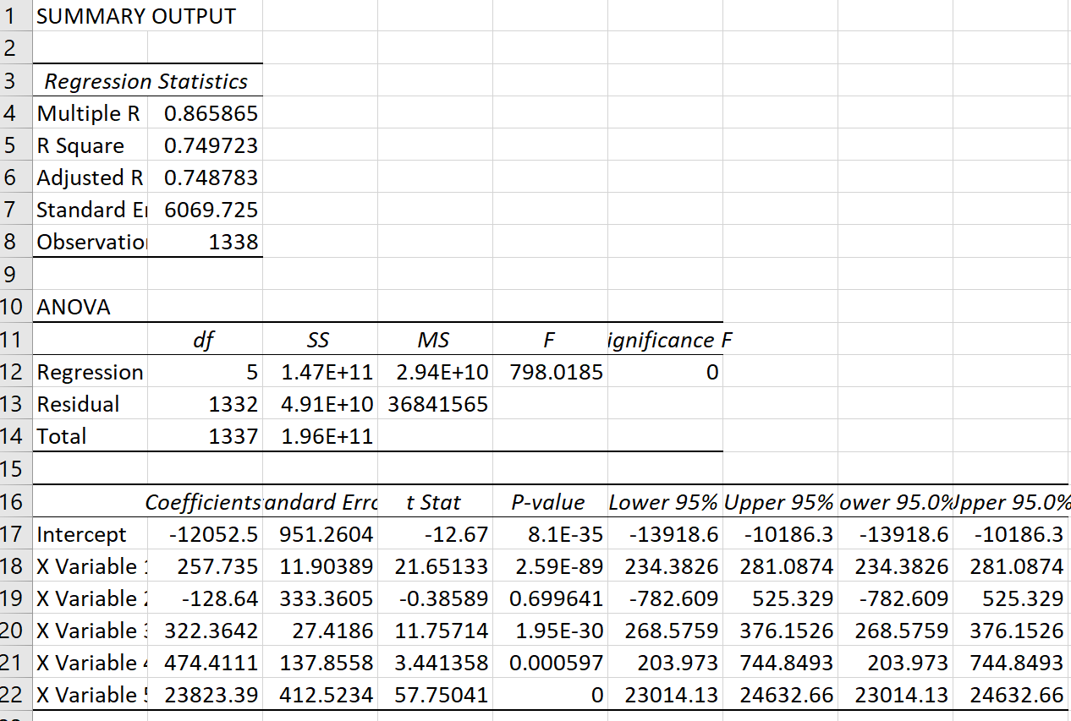

In the first part, the Adjusted R square is the factor used in indicating how good the model fits.
In the second part of ANOVA (analysis of variance), the df is the degree of freedom, F is the F statistic.
The most useful component in this section is Coefficients. We can see that gender (p = 0.6996) is not statistically significant at α = 0.05.

Part III: Linear regression with Python:
Introduction to Pandas
- Python Pandas provides high level, flexible and fast sets of tools to manipulate data into the right format. Pandas Focuses on loading/reading data, exploring data, basic data operations, data selection, data transformation, handling missing values, data visualization and etc..
- DataFrame provides rectangular table of data containing an ordered collection of columns of different value types (numeric, string, boolean…)
- For each column in the dataframe, we may refer it with the column name: df.age or df[‘age’]
- The data statistics of different columns can use: df.age.mean()
- We can check the correlation between the numerical variables: df.corr()
- We will try some Pandas built in plotting functions: plot(), hist(), boxplot()
- Other common operations:
  - Replace values: df.gender.replace([‘M’, ‘F’], [1,0])
  - drop_duplicates(): df.drop_duplicates()
  - check the missing values: df.isnull().sum()
  - drop the missing values: df.dropna(inplace = True)
- Start your jupyter notebook or google colab
- Import the following packages: pandas, seaborn and pyplot from matplotlib
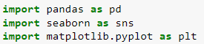
- Read the data set and preview the data
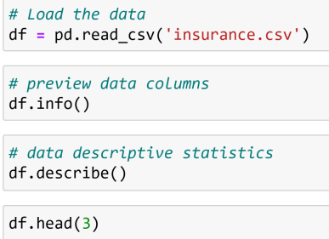
(For students who use colab, you need save the insurance.csv to your google drive, and add the
drive to colab. Please use the following as reference:
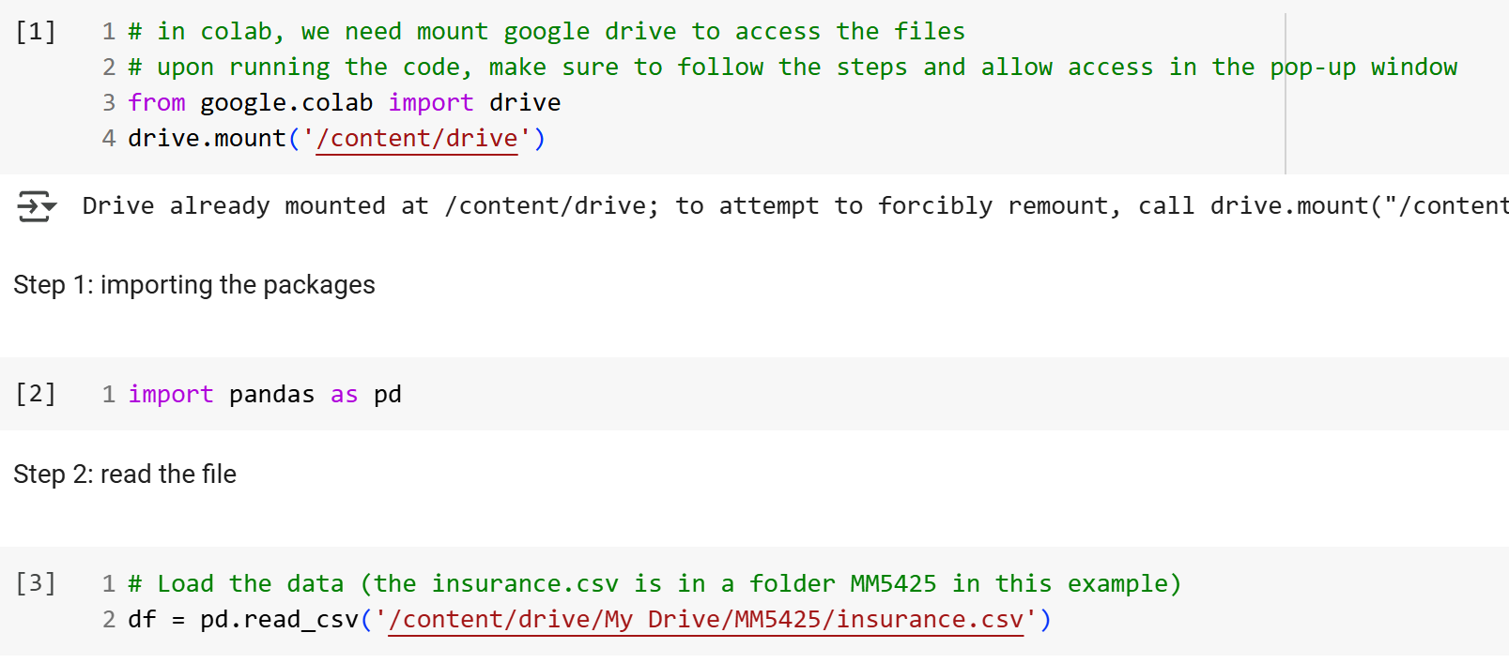 )
- In the data preparation, we replace the categorical values of Gender and Smoker to be values of 1 or 0

- For another categorical values of Region, we need use dummy variables
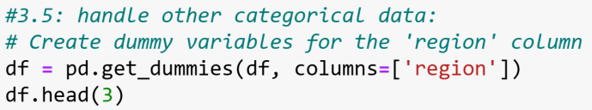
- To use the linear regression model, we need find the target variable and the dependent variableshttps://www.timeanddate.com/worldclock/hong-kong/hong-kong
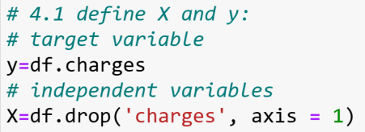
- (optional) We will split the data for training and testing in our model training:
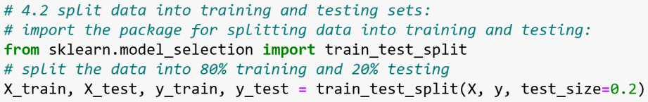
- Train the model
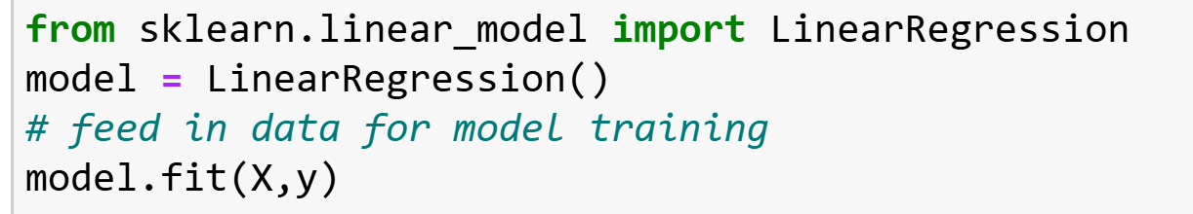
- At this step, we simply check the intercept and slopes in Step 5:
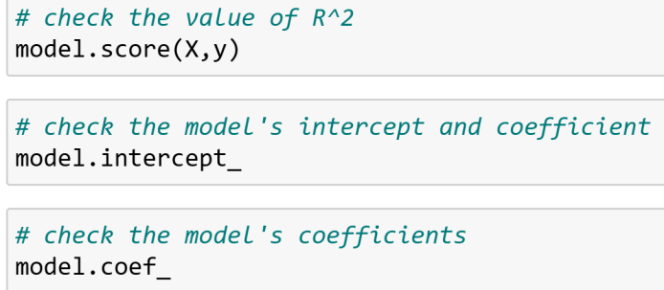
- To have a summary of the model:
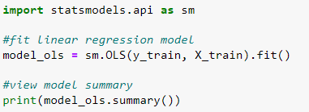
- Is the result consistent with that from Excel? What is the charges equation as predicted?
Charges =

- If you have a new customer who is 32 years old male with bmi=28.9, two children, non-smoking, from southeast district. How much is the predicted insurance charge for him?
import numpy as np
new_customer = np.array([32,1,28.9,2,0,0,0,1,0]).reshape(1,-1)
print(model.predict(new_customer))
Submission: please submit your Jupyter notebook file with results

